**Greater Sydney, Place and Infrastructure** IRF19/4539

Gateway determination report

|  |  |
| --- | --- |
| **LGA** | Liverpool |
| **PPA** | Liverpool City Council |
| **NAME** | To allow vehicle sales and hire premises as an additional permitted use (7 jobs) |
| **NUMBER** | PP_2019_LPOOL_ 003_00 |
| **LEP TO BE AMENDED** | Liverpool LEP 2008 |
| **ADDRESS** | 36 and 36A Kookaburra Road, North Prestons |
| **DESCRIPTION** | Lot A DP408207 and Lot B DP408207 |
| **RECEIVED** | 21 June 2019 (updated proposal received on 2 October 2019) |
| **FILE NO.** | IRF19/4539 |
| **POLITICAL DONATIONS** | There are no donations or gifts to disclose and a political donation disclosure is not required |
| **LOBBYIST CODE OF CONDUCT** | There have been no meetings or communications with registered lobbyists with respect to this proposal |

**1. INTRODUCTION**

**1.1 Description of planning proposal**

The planning proposal **(Attachment A2)** seeks to amend Schedule 1 Additional permitted uses of Liverpool Local Environmental Plan (LEP) 2008 to include vehicle sales and hire premisesas an additional permitted use on land at 36 and 36A Kookaburra Road, North Prestons (Lot A and Lot B DP408207).

**1.2 Site description**

The site is 4.045ha in area (Lot A is 2.022ha and Lot B is 2.023ha) and it is within the Prestons Industrial Area. The site (Figure 1 next page) is bounded by Yarrunga Street to the north, Kookaburra Road to the west and other industrial warehouses and distribution centres to the south and east. The site location map is at **Attachment D1**.

**1.3 Existing planning controls**

The site is zoned IN3 Heavy Industrial under Liverpool LEP 2008 (Figure 2 next page). A State Significant Development application (SSD7155 MOD 3) which enabled the construction of a warehouse building for Volvo was approved on 13 February 2018 (Figure 3 next page). The Volvo facility includes uses for both warehouse and distribution, and vehicle servicing. These uses are permitted with consent under the existing IN3 zone for the site.

However, vehicle sales and hire premises is not a permissible use in the IN3 zone. A temporary use of land development application (DA) to permit vehicle sales and hire premises use as a temporary use (52 days in a year) was approved by Council, while the planning proposal was being considered.

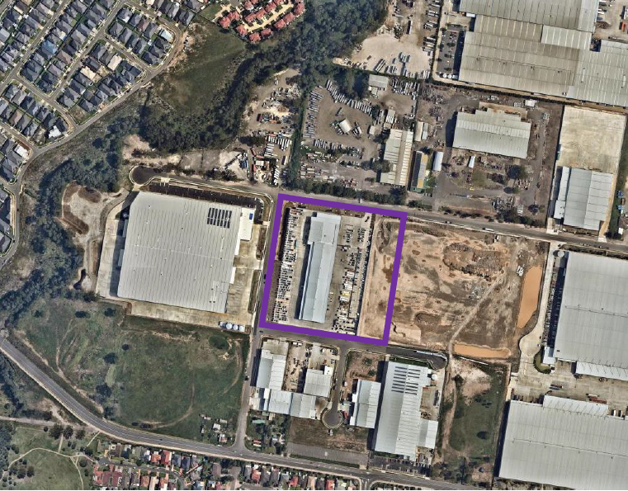

Figure 1: Subject site (in purple)

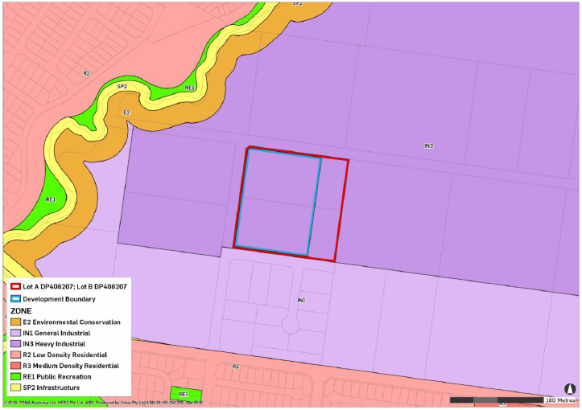

Figure 2: Current zoning of the site (in red)

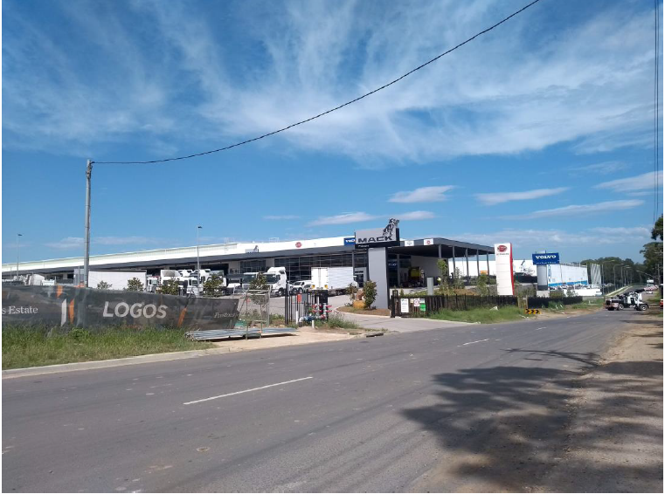

Figure 3: Street view of the existing development

**1.4 Surrounding area**

The site is within the Prestons Industrial Area and the surrounding land is dominated by industrial development (i.e. warehouses and distribution centres). This area is zoned IN2 Light Industrial and IN3 Heavy Industrial.

**1.5 Summary of recommendation**

It is considered that the planning proposal is suitable to proceed to Gateway

determination for the following reasons:

* the site is located within the Prestons Industrial Area and contributes to the industrial sector in the Western City District;
* the proposed vehicle servicing use will provide an additional facility for the surrounding industrial area to purchase heavy vehicles in the area;
* the proposal will enable the expansion of the uses on the site and encourages employment opportunities for seven additional jobs;
* the proposed additional use is compatible with the surrounding industrial uses; and
* the proposed use is a small component of Volvo’s operation and will not reduce industrial land or impact on the current employment uses in the surrounding area.

**2. PROPOSAL**

**2.1 Objectives or intended outcomes**

The objective of the planning proposal is to amend Schedule 1 Additional permitted uses of the Liverpool LEP 2008 to allow vehicle sales and hire premises as an additional permitted use on the site in order to enable retail activities to occur.

**2.2 Explanation of provisions**

The planning proposal seeks to amend Schedule 1 Additional permitted uses of Liverpool LEP 2008 to allow vehicle sales and hire premises as an additional permitted use on the site by inserting the following:

*Use of certain land at Prestons in Zone IN3*

1. *This clause applies to Lot A and B, DP 408207 in Zone Heavy Industrial at Kookaburra Road, North Prestons.*
2. *Development for the purposes of a Vehicle Sales or Hire Premises is permitted with consent as an ancillary component to the dominant industrial use of the site.*
3. *The proposed additional permitted use of vehicle sales or hire premises is to be confined to within the existing warehouse building and limited to 500 square metres of the hardstand area;*
4. *The external storage area shall not be used for the display of vehicles for sales, and no sales of vehicles is allowed to be conducted from the site other than from the inside of the warehouse building and within the nominated 500 square metres of the hardstand area.*

Department comment

Prior to public exhibition, Council is required to expand the description of the proposed clauses to explain in detail the intent of the controls as desired by Council. Council should also note in the proposal that these clauses are subject to change following legal drafting.

**2.3 Mapping**

The planning proposal does not include any changes to the existing maps. The existing zoning map is at **Attachment D2**.

**3. NEED FOR THE PLANNING PROPOSAL**

The proposed use for vehicle sales and hire premisesis not a permitted use in the zone. A planning proposal is required to make the proposed use as an additional permissible use and is considered the best means of facilitating Council’s intended outcome.

**4. STRATEGIC ASSESSMENT**

**4.1 District**

Western City District Plan

The Greater Sydney Commission released the Western City District Plan on 18 March 2018. The plan contains planning priorities and actions to guide the growth of the Western City District while improving the district’s social, economic and environmental assets.

The planning proposal is consistent with Priority W10 which seeks to maximise freight and logistics opportunities and planning and managing industrial and urban services land. The proposed additional use is compatible with the surrounding industrial uses and will not reduce existing industrial land supply as it is proposed within an existing approved building. The District Plan acknowledges that urban services land, including motor vehicle services, is occurring within industrial land and its importance to Sydney’s economy.

The District Plan also states that the demand for urban services will grow commensurate with population growth and are less likely to be accommodated within multi-storey buildings. The proposed use within the existing industrial building floor space will not impact or reduce the existing industrial land. It will facilitate retention of the existing industrial use of the site. The site’s industrial zoning is also not proposed to be amended, allowing for future industrial uses.

It is considered that the proposal would give effect to the District Plan, in accordance with section 3.8 of the *Environmental Planning and Assessment Act 1979.*

**4.2 Local**

Draft Industrial Lands Study

Council advises that the proposal is consistent with the Draft Liverpool Industrial Land Study being prepared by SGS Economics and Planning. The study is to investigate Liverpool LGA’s industrial land and to provide various recommendations to ensure the sufficient supply of industrial land; to effectively manage existing industrial precincts; and to encourage economic development initiatives. The planning proposal will not reduce the existing supply of industrial land.

Local Planning Panel

On 25 March 2019, Liverpool Local Planning Panel resolved to support the planning proposal to proceed to Gateway determination as the proposal has strategic and site-specific merit, provided that the schedule amendment contains criteria designed to limit the size and scale of any future vehicle sales or hire premises on the site **(Attachments E1 & E2)**.

Council agreed with the Panel’s recommendation to limit the size and scale of the proposed additional permitted use to enable appropriate flexibility whilst avoiding adverse impacts and ensuring the use remains ancillary to the primary use of the site **(Attachments A3 & A4)**.

**4.3 Section 9.1 Ministerial Directions**

**Inconsistent:** The planning proposal is inconsistent with the following Section 9.1 directions as discussed below.

Direction 3.4 Integrating Land Use and Transport

The objectives of this direction seek to reduce travel demand by car through improving access to housing, jobs and services by walking, cycling and public transport.

The site is not serviced by public transport for the additional seven onsite jobs, however, the proposal will facilitate the colocation of vehicle sales close to Sydney’s main freight corridors which will provide for overall efficient integration of land use and transport infrastructure. It is therefore considered that the proposal’s inconsistency with the direction is of minor significance.

Direction 4.3 Flood Prone Land

The objective of this direction is to ensure that development of flood prone land is consistent with the NSW Government’s Flood Prone Land Policy and the principles of the Flood Planning Development Manual 2005, and to ensure that provisions of an LEP on flood prone land is commensurate with flood hazard and includes considerations of the potential flood impacts both on and off the subject land.

Council’s planning proposal states that flooding impacts have been assessed in detail during the assessment of SSD 7155 (as modified) but gave no further information on flooding on the site.

The Local Planning Panel’s report dated 25 March 2019, however, advises that north-western portion of the site is identified as a flood planning area with low and medium flood risk. The proposal will be wholly contained within the existing building on the site. The report further states that Council’s Flooding Section have reviewed the proposal and provided support noting that the site is affected by the 1% AEP flooding from Cabramatta Creek.

The proposal will not have any adverse impact on flooding and there is no objection to the proposal from a flooding perspective given that the issue of flooding has been resolved during the construction of the warehouse building and associated parking areas. It is, therefore considered that the inconsistency of the planning proposal with the direction is of minor significance.

Direction 6.3 Site Specific Provisions

The objective of this direction is to discourage unnecessarily restrictive site-specific planning controls. The planning proposal seeks to allow the vehicle sales and hire premises land use as additional use in the IN3 zone.

The proposal is inconsistent with this direction as it includes additional provisions aimed to limit the additional use to occur within the footprint of the approved existing warehouse building (i.e. 500m2 hardstand area) to limit the impact on the surrounding area. The inconsistency is justified as the site-specific provision seeks to limit the scale of the proposed development and not ensuring the use remains ancillary to the primary industrial use of the site.

**Consistent:** The planning proposal is inconsistent with the relevant Section 9.1 directions including the following outlined below.

Direction 1.1 Business and Industrial Zones

The objectives of this direction encourage employment growth in suitable locations, and support the viability of identified centres. The direction applies when a relevant planning authority prepares a planning proposal that will affect land within an existing or proposed business or industrial zone (including the alteration of any existing business or industrial zone boundary).

The proposal will allow additional uses on the industrial zoned site and will not impact on the existing uses or reduce industrial land. The planning proposal supports the Volvo business and encourages employment opportunities and is consistent with the surrounding land uses in the area. The proposal is consistent with the direction.

**4.4 State environmental planning policies (SEPPs)**

State Environmental Planning Policy No 55 – Remediation of land

Council advises that Lots A and B DP 408207 were previously used for agricultural purposes. The land was cleared of native vegetation in 2017, with the exception of a small portion along the north-western corner of the site. The stripping, including the removal of the remaining vegetation, remediation and the capping of Lots A and B was approved under a Complying Development Certificate CDC-1227/2017 and works were carried out accordingly.

The Preliminary Geotechnical and Environmental Investigation **(Attachment F)** was prepared for SSD 7155 was assessed by the Department for a warehouse, storage and distribution of vehicle parts. Council considers that this satisfies Cl.6(2) of the SEPP that the land is suitable for the purposes for which this planning proposal seeks to permit. It is considered that Council has satisfied the requirements of Cl.6(2) of the SEPP.

**5. SITE-SPECIFIC ASSESSMENT**

**5.1 Social**

The proposal is of a minor nature. It will create additional seven local jobs in the Prestons Industrial Area. No other social amenities are proposed as part of the proposal.

**5.2 Environmental**

The proposal is unlikely to have any significant impact on the natural environment. The land was cleared of native vegetation in 2017, except a small portion along the north-western corner of the site, with no linkages to other native vegetation corridors as shown in Figure 1. The proposed use will be contained within the existing warehouse and therefore there is a very low likelihood of any adverse impacts on ecological communities or their habitats. Council advises biodiversity and environmental values on the site has been assessed as part of the SSD 7155 assessment and conditioned accordingly.

**5.3 Economic**

Vehicle sales on the site would support the existing Volvo operations in Prestons Industrial Estate and contribute to the growth of the industrial sector in the Western City region. The overall development is expected to generate 100 operational jobs and significant full time equivalent jobs during construction and the vehicle sales component is expected to employ seven staff. These uses combined will ensure positive economic benefits for the Prestons Industrial Estate, and the region as a whole.

**5.4 Infrastructure**

Council advises that the planning proposal highlights that a full review of available services infrastructure was undertaken during SSD 7155 (as modified) as well as the DA consent for temporary use, both of which concluded that all utilities are available and satisfactory at the site. It is noted that the closest bus stop is located over 800m walking distance from the site along Braidwood Drive.

The area is poorly serviced by public transport. The proposal is of minor nature and additional retail component proposed will not place unacceptable strain on the existing service provision to the overall development.

Council advises that the Traffic Impact Statement prepared as part of the SSD found that there will be no resultant adverse traffic implications for the site accesses or the surrounding road network. No traffic assessment is submitted as part of this proposal.

**6. CONSULTATION**

**6.1 Community**

Council has identified 28 days for community consultation. This is considered appropriate.

**6.2 Agencies**

Council has not identified agencies to be consulted. It is considered that Roads and Maritime Services (RMS) be consulted.

**7. TIME FRAME**

Time frame for completing the LEP as proposed by Council is 9-12 months. A 9-month period is considered appropriate.

**8. LOCAL PLAN-MAKING AUTHORITY**

Council has not requested to be the local plan-making authority. Considering the minor nature of the proposal, Council should be authorised to be the local plan-making authority.

**9. CONCLUSION**

The planning proposal is supported to proceed with conditions as:

* the proposal will facilitate and complement the primary existing operations on and surrounding the site; and
* the proposed additional use is compatible with the surrounding industrial uses and will not reduce existing industrial land supply.

**10. RECOMMENDATION**

It is recommended that the delegate of the Secretary:

1. agree that any inconsistencies with section 9.1 Directions 3.4 Integrating Land Use and Transport, Direction 4.3 Flood Prone Land and 6.3 Site Specific Provisions are minor.

It is recommended that the delegate of the Minister determine that the planning proposal should proceed subject to the following conditions:

1. The planning proposal should be made available for community consultation for a minimum of 28 days.
2. Consultation with Roads and Maritime Services is required.
3. The time frame for completing the LEP is to be 9 months from the date of the Gateway determination.
4. Given the nature of the planning proposal, Council should be the local plan-making authority.
5. Prior to public exhibition, Council is required to amend the planning proposal as follows:
6. use Council’s template for the exhibited version of the planning proposal;
7. update the references to the address of the subject land to 36 and 36A Kookaburra Road, North Prestons;
8. expand the description of the proposed clauses to explain in detail the intent of the controls; and
9. update the consistency of the planning proposal with section 9.1 Directions 3.4 Integrating Land Use and Transport, Direction 4.3 Flood Prone Land and 6.3 Site Specific Provisions.

Machine generated alternative text:

25/10/2019

**Jazmin van Veen**

**Acting Director, Western**

**Central River City and Western Parkland City**

Assessment officer: Cho Cho Myint

Senior Planner, Western

Phone: 98601507